

**PROJECT TEAM MEMBER**

**ESSENTIALS**

**Course Worksheets**

**Dynamic Solutions**

**Susan A. Junda**

[**SJunda@DynamicSolutionsNM.com**](mailto:SJunda@DynamicSolutionsNM.com)

**PROJECT TEAM MEMBER ESSENTIALS**

**NOTE:** This document is designed to give you an easier time:

* doing the work in the breakout rooms (i.e. with a team) as you will have the information here to refer to , and
* using this as place to take notes and do some exercises (especially if you like to work “hard copy”).

**So keep it handy during the class!**

**MODULE 1 –**

**Making the Transition from Functional Employee to Team Member**

1. **BO1 - Benefits of using Project Teams (to accomplish work)**
2. **BO2 - Reasons why Project Teams might not be successful**
3. **BO3 - What constitutes project success?**
4. **BO 4 - Attributes of a successful Project Team**

**Time to reflect:**

* What are some of the issues that you have experienced in making the transition from functional employee to Project Team member?
* What might be some possible solutions or actions you could take or have taken to alleviate the above issues?

**Making the Transition from Functional Employee to Project Team Member**

**Skills needed to be an Skills needed to be an effective**

**effective functional employee project team member**

------------------------------------------------------------------------------------------------

Ability to follow the rules Ability to be flexible and meet

of the operation/department needs of the project

Allegiance is to pleasing the boss Allegiance is to supporting the success

of the project and the team with functional

manager support

Be technically competent Be the technical "expert" and functional

representative

May need to communicate Ability to communicate verbally, in

very infrequently to few people writing and in person with all team members

Can ignore issues that create conflict Need to address and resolve conflicts

so that the project and the team can succeed

Receive feedback in reviews Ability to give and receive constructive

feedback regularly

Tendency to "play it safe" Ability to assess and take risks

May work in a "vacuum" -- Must participate in the group process -

(just doing your own thing) i.e., brainstorming, developing options,

problem solving, etc.

Decisions are "made above" and handed Decisions are made by consensus after

"down" all voices are heard

Rewards based on individual contribution Rewards based on contribution to project,

the group and peer recognition

Works on regular on-going tasks Works on completing project tasks on time, within budget at a high quality level

Focus of work and time is spent on Focus of work and time is balanced

operational/departmental work between the responsibility to operational

work and the responsibility to the project

**MODULE 2 – Understanding Teams**

**The Structure of Teams**

3 STRUCTREOFTEAMS

**Communications Triangle**

3 CommTriangle

**Assessing Team Behaviors**

**Best Team Behaviors:**

**Worst Team Behaviors:**

|  |  |
| --- | --- |
| **New Team Behaviors** | **High Performing**  **Team Behaviors** |
|  |  |
|  |  |
|  |  |
|  |  |
|  |  |
|  |  |
|  |  |
|  |  |
|  |  |
|  |  |

**Team Stages**

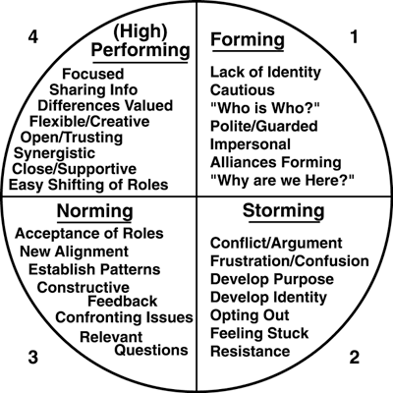

**Managerial Styles:**

* **Task oriented**
* **People Person**
* **“Hands Off” Leader**

**What would cause a team to go “backwards”?**



**Successful Project Team Behaviors**

**EXERCISE:** Rate your Team (think of the team at a meeting) on a scale of 1-5

5 = GREAT! We do this all of the time

4 = We do this most of the time

3 = We do this some of the time (50-50)

2 = We rarely do this; (maybe “should do it more often”)

1 = I have never seen this exhibited by my team

The team I am assessing is: ___________________________________

**RATING**

1. Clarity of project goal and team purpose
2. Clearly defined roles and responsibilities
3. Clear channels of communication
4. Problem solving and conflict resolution skills
5. Constructive feedback methods
6. Sharing of some roles (administrative)
7. Well-defined decision procedures
8. Balanced participation at team meetings
9. Awareness of the group process

**TOTAL: _________**

**Areas that the team is doing well:**

**Areas in which the team could use improvement:**

**MODULE 3 – Basic Project Management Concepts & Tools**

**The Basic Project Life Cycle**

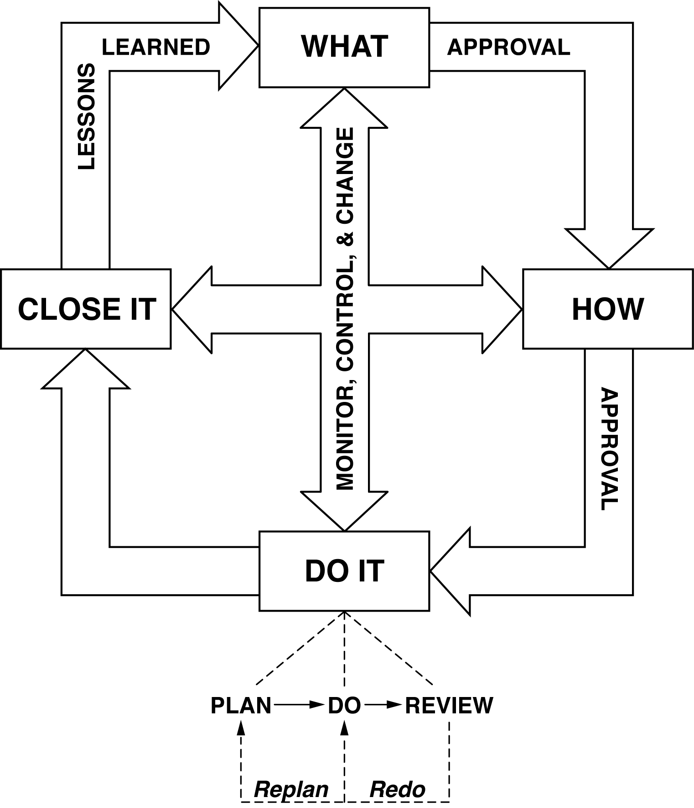

**The Critical Triangle**

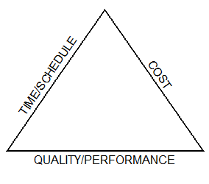

**Project Charter Template**

* Goal Statement

Two parts to the Goal Statement:

* + What is the work that the team will accomplish?
  + AND
  + What is the endpoint signifying completion?
* “Action” Objectives
  + Break Goal into 4-**9** major objectives
  + Each must start with a VERB!!
  + Must include “doing it” AND the endpoint
* Key Deliverables - list what team will deliver
* Scope
  + What is and what is not included
  + Prevents “scope creep”
* Assumptions- Factors that for planning purposes are considered to be true, real or certain.
* Constraints- Facts that limit the project or the team’s options.
* Risk Assessment

**Detailed Project Plan (process/methodology)**

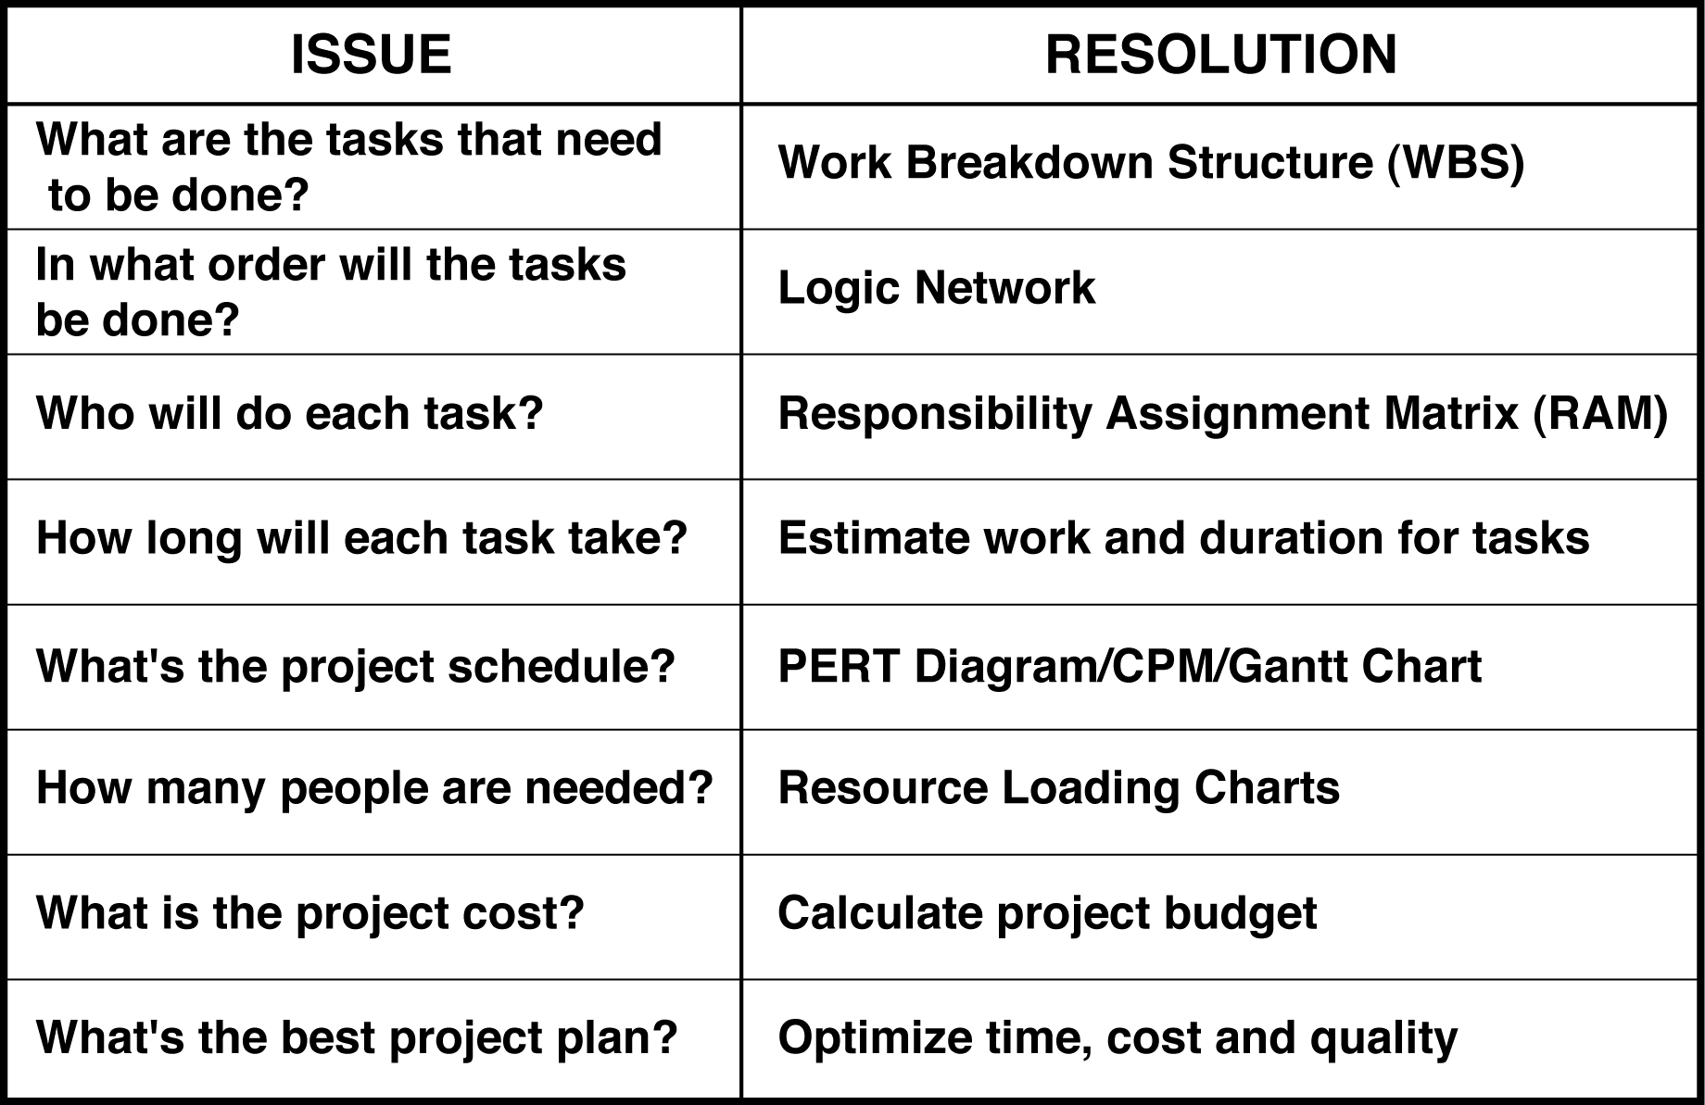

**Sample WBS**

5 WBS

**Sample Logic Network**

5 SMPL LGC NTWK

**==================================================**

**Demo: The Logic Network**

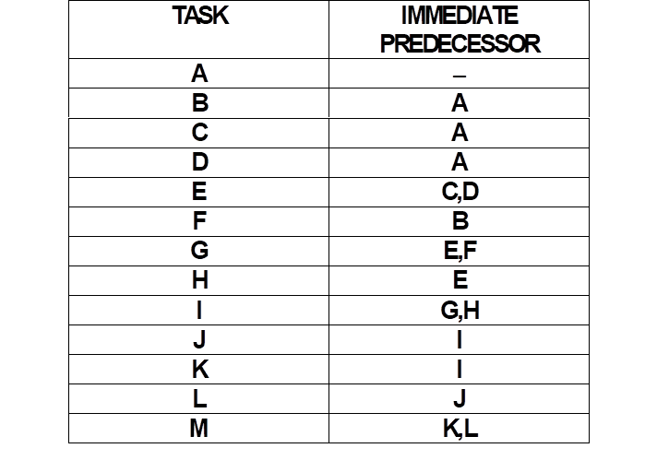

**Responsibility Assignment Matrix (RAM)**

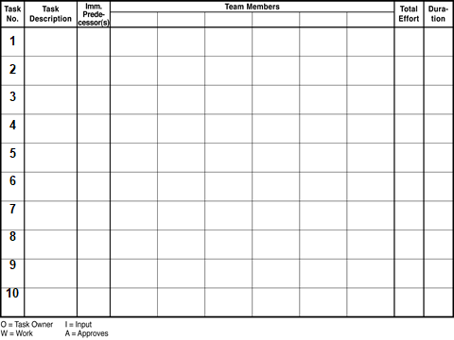

**2 types of Estimates**

Labor/work effort – goes into the BUDGET

Duration – goes into the SCHEDULE

**Estimating Standard**

1.0 = 1 week/5 days/40 hours

.2 = 1 day/8hours

.1 = ½ day/4 hours

===========================

* Do NOT estimate less than .1
* Do NOT go to a second decimal point.
* Do NOT consider holidays, vacation or overtime.

**Demo the PERT Diagram**

6 PERT diagr examp

**Forward Pass: ES + DUR = EF**

**Backward Pass: LF – DUR = LS**

**Float = LF-EF**

**PRACTICE: Do the PERT diagramming**

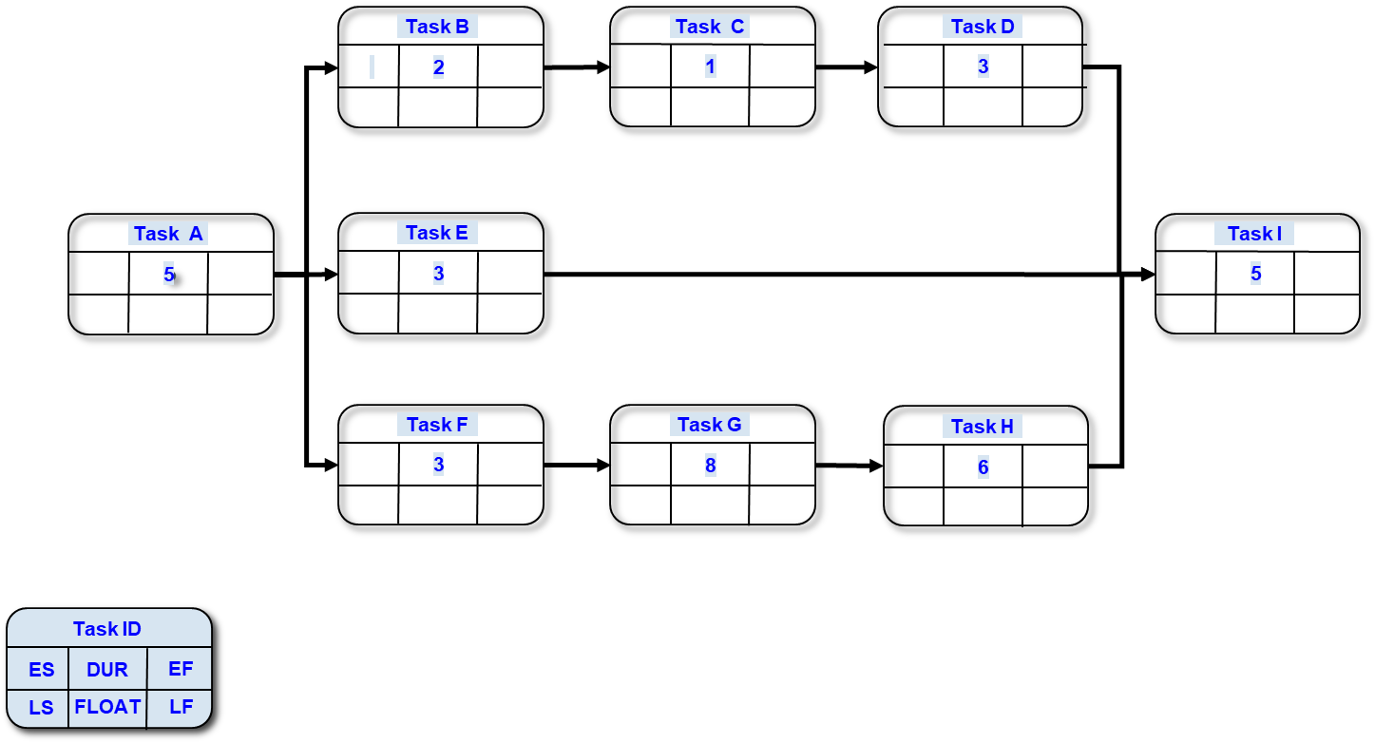

**Forward Pass: ES + DUR = EF**

**Backward Pass: LF – DUR = LS**

**Float = LF-EF**

**=====================================================**

**EXERCISE:**

* BO1 - What are the benefits of using the “old school” style of Project Management?
* BO2 - What are the risks of using the “old school” style of Project Management?
* BO3 - What is a Project Team member’s responsibility in the Project planning process?
* BO4 - What are the benefits of a Project Manager getting the team member’s involved in the project planning process?

**MODULE 4 – Skills for Getting Project Work Accomplished**

### Identify Your Time Wasters

* Pick the top 10 (Rank them number 1-10)

Telephone calls ___________

Meetings ____________

Crisis situations ____________

Unclear communications ____________

Drop-in visitors ____________

Inability to say “No” ____________

Unclear responsibility for the tasks ____________

Lack of prioritizing the work ____________

Lack of clear deadlines ____________

Leaving tasks unfinished ____________

Doing too much at once ____________

Too much reading (Faxes, email, etc.) ____________

Lack of self-discipline ____________

Ineffective delegation ____________

Indecision and procrastination ____________

Perfectionism-need to do it perfectly ____________

Personal disorganization ____________

Untimely or unreliable information ____________

Other:_____________________ ____________

* My top TWO time wasters are :

**CONSEQUENCES**

**Positive Negative**

**Immed**

**I**

**A**

**T**

**E**

**De l ayed**

**T  
I  
M  
I  
N  
G**

**EXERCISE:** **Overcoming Procrastination**

**TASK I procrastinate in doing:**

**REASONS why I procrastinate on this task:**

**POSSIBLE CONSEQUENCES of my procrastination:**

**(positive and negative, immediate and delayed):**

**ACTIONS I will take to overcome the procrastination:**

**Status Reporting**

**3 levels:**

* From the Team Members to the Project Manager
* From the Project Manager to the Team Members (Project Summary Report)
* From the Project Manager to Stakeholders

***Benefits of submitting weekly Status Reports:***

1. Information from team members aids the project manager in keeping the Project Plan current and valid.
2. The Status Reports can serve as historical records on what events transpired during the course of the project.
3. The team members can use their Status Reports in reporting their accomplishments for their yearly performance reviews.
4. The Status Reports can act as a time management tool.
5. Team members will know how well they estimated their tasks. Their Status Report becomes a time management tool.

5) The Status Report written on Friday serves as a "to do" list for the next week’s work

**A Case Study: The Team Member Caught in the “Middle”**

You were recently assigned by your department manager, John Economy, to be a team member on the new product development team to work on the Starlight Project. Jim Ersfield, the department’s previous representative on this team, was reassigned to work on two other “hot” upcoming projects. The Starlight Project is ready to begin Phase 3, Project Execution. Mr. Economy told you that he sees you as being quite capable of representing the department with your functional area knowledge and expertise. He believes not only that you can handle this assignment, but also keep up with the responsibilities that you have been performing for the department. This is your first assignment to a Project Team.

Ms. Sophia Abrams is the Project Manager for the Starlight Project. While she welcomes you to the team, she is a “no excuses” type of manager and wants what she wants when she wants it. She is demanding and is not known for being easily approachable. Project Starlight is on the fast track, with aggressive timeline dates needing to be met.

**Part 1 - As a team, answer the following questions and document them:**

**1. What additional information would be helpful for you to make the transition into your new position as a project team member?**

**2. How would you go about gathering this information?**

**Let’s continue…**

Time moves on. The project is moving forward at a very rapid rate. You are juggling not only your department responsibilities, but your effort is now needed on the project is at 75% of your time. You are doing the best you can but are waiting on 2 other team members to give you some necessary information in order to complete your project tasks.

Mr. Economy has been pleased with your coming up the learning curve so rapidly, so pleased that he asks you to start attending 2 other project start-up meetings and help the teams to create their Project Management Plans. You say “yes” and now, one month later, wonder why you did.

Ms. Abrams has been leaving you voicemails and sending emails wondering where you are on your tasks and why you missed the last 2 team meetings. She sounds extremely irritated. Mr. Economy has been out of town for the last 2 weeks and will be back next Monday (“today” is Thursday), expecting some deliverables on his desk for some department policies and procedures you have been developing, which are still in rough draft.

Bottom line, you are not sure how to handle all of this and wonder what you should do next.

**Part 2 - As a team, answer the following questions and document them:**

**3. How do you think you should deal with Sophia Abrams? Mr. Economy?**

**4. What would you plan to do the following week, given this situation? What order would you do it in and how would you prepare?**

**Project Team Member – Action Planning**

1. As a result of this training, what do I need to do when I go back to my job (within the next 2-3 days)? Within the next few weeks?
2. Who do I need to update, brief or educate?
3. What additional training might I or my colleagues or team members need?
4. As a result of this training, what do you recommend as “next steps” for Managers in your department to foster more project team “successes” (on time, within budget, delivering expected results in a quality way)?

Other courses from Dynamic Solutions:

* PMFund010 – Introduction to Project Management Terminology (3.5 hours)
* PMFund011 – Project Management Overview (3 days – uses the PMBOK)
* **PMFund012** – Managing a Project from Start to Finish (3 days – experiential)
* **PM151** – Project Leadership Essentials (2 day)
* PM152 – Project Team Member Essentials (2 day)

Contact info:

* **Project Management Institute**
  + ***Phone: 610-356-4600***
  + ***Website: www.pmi.org***
* **Susan Junda - Dynamic Solutions**
  + ***Phone: 505-459-0436***
  + ***Email: SJunda@DynamicSolutionsNM.com***
  + [***www.DynamicSolutionsNM.com***](http://www.DynamicSolutionsNM.com)

**MOST IMPORTANT POINTS**

**Module 1:**

**Module 2:**

**Module 3:**

**Module 4:**

**Module 5:**