Introduction to
Project Management Terminology

Course Worksheets

Dynamic Solutions
Susan A. Junda
SJunda@DynamicSolutionsNM.com
Project Life Cycle

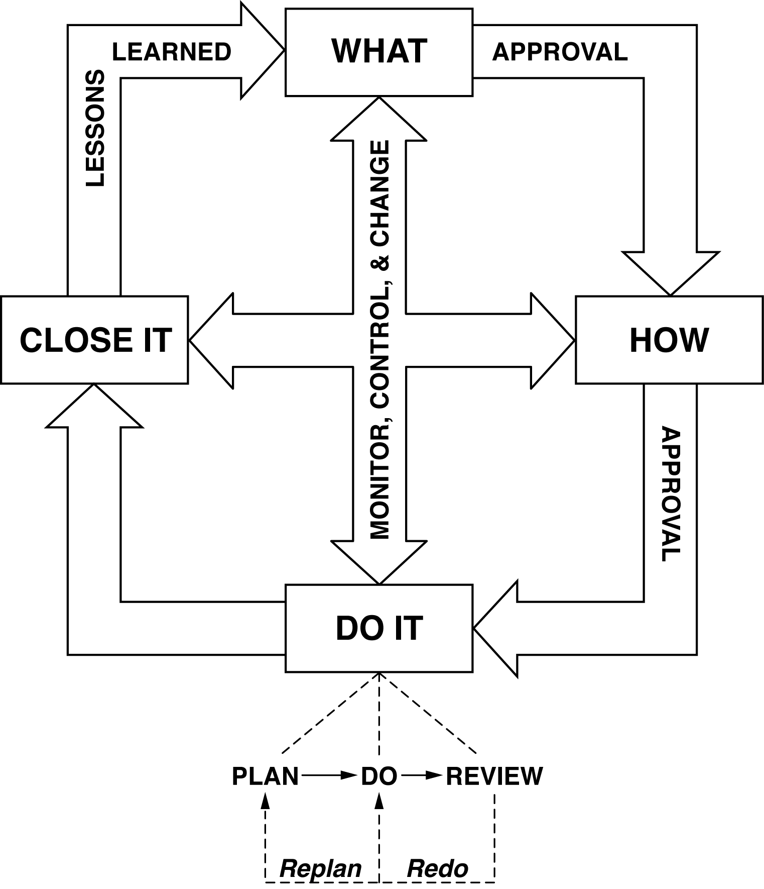
Exercise 1: Match the term with its definition or attributes

TERM | DEFINITION/ATTRIBUTE
____ 1. Project Manager | A. Turns cartwheels at the thought of your project
____ 2. Project Champion | B. The centralized management of a collection of projects or programs
____ 3. Product | C. The person responsible for providing the financial resources for the project
____ 4. Project Management | D. A temporary endeavor undertaken to create a unique product service or result
____ 5. Deliverable | E. A group of related projects or processes managed in a coordinated way
____ 6. Functional Manager | F. Any unique and verifiable product, result, or capability to perform a service
____ 7. Process | G. The person assigned by the organization to manage the project
____ 8. Project | H. The person who represents a functional department whose skills are necessary for planning and implementation of the project.
____ 9. Project Sponsor | I. An ongoing series of actions which lead to an end result
____10. Program | J. The application of knowledge, skills, tools and techniques to project activities to meet project requirements
____11. Portfolio Management | K. The person that “loans” out their employees to work on project teams
____12. Team Member | L. A quantifiable artifact that is produced
Exercise 2: Interpreting the Stakeholder Analysis
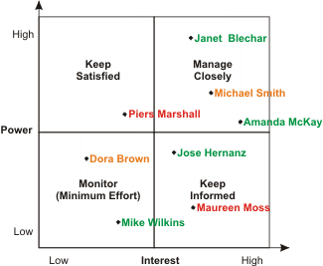
*

With your team, answer the following questions:
- What is your interpretation of the data in this Stakeholder Analysis?

- What can you do to convince the “low interest” stakeholders of the importance of your project?

- How would you deal with the powerful, highly interested supporters?

Exercise 3 – Project or Operation?

Which of the activities below are projects? Which ones are operations? Which ones are neither?

Quarterly inventory cycle counts

Moving the engineering lab to a new location

Improving sales by 10%

Bringing a new product to market

The Help Desk’s 24/7 operations

A department’s annual Holiday Party

Distribution of payroll checks

Implementation of a software package

Adding regulatory labels to a product

Adding a new option to a current product

Action Planning

- As a result of this training, what do I need to do when I go back to my job, within the next 2-3 days?

Within the next few weeks?

- Whom do I need to update or brief?

- What, if any, courses do I need to sign up for next?

