

**MANAGING A PROJECT**

**FROM START TO FINISH**

**2-day version**

**Course Worksheets**

**Dynamic Solutions**

**Susan A. Junda**

[**SJunda@DynamicSolutionsNM.com**](mailto:SJunda@DynamicSolutionsNM.com)

**MANAGING A PROJECT FROM START TO FINISH**

**NOTE:** This document is designed to give you an easier time doing the work in the breakout rooms (i.e. with a team) as you will have the information here to refer to as needed. So keep it handy during the class!

**MODULE 1 – Project Management Concepts**

**PROJECT LIFE CYCLE**

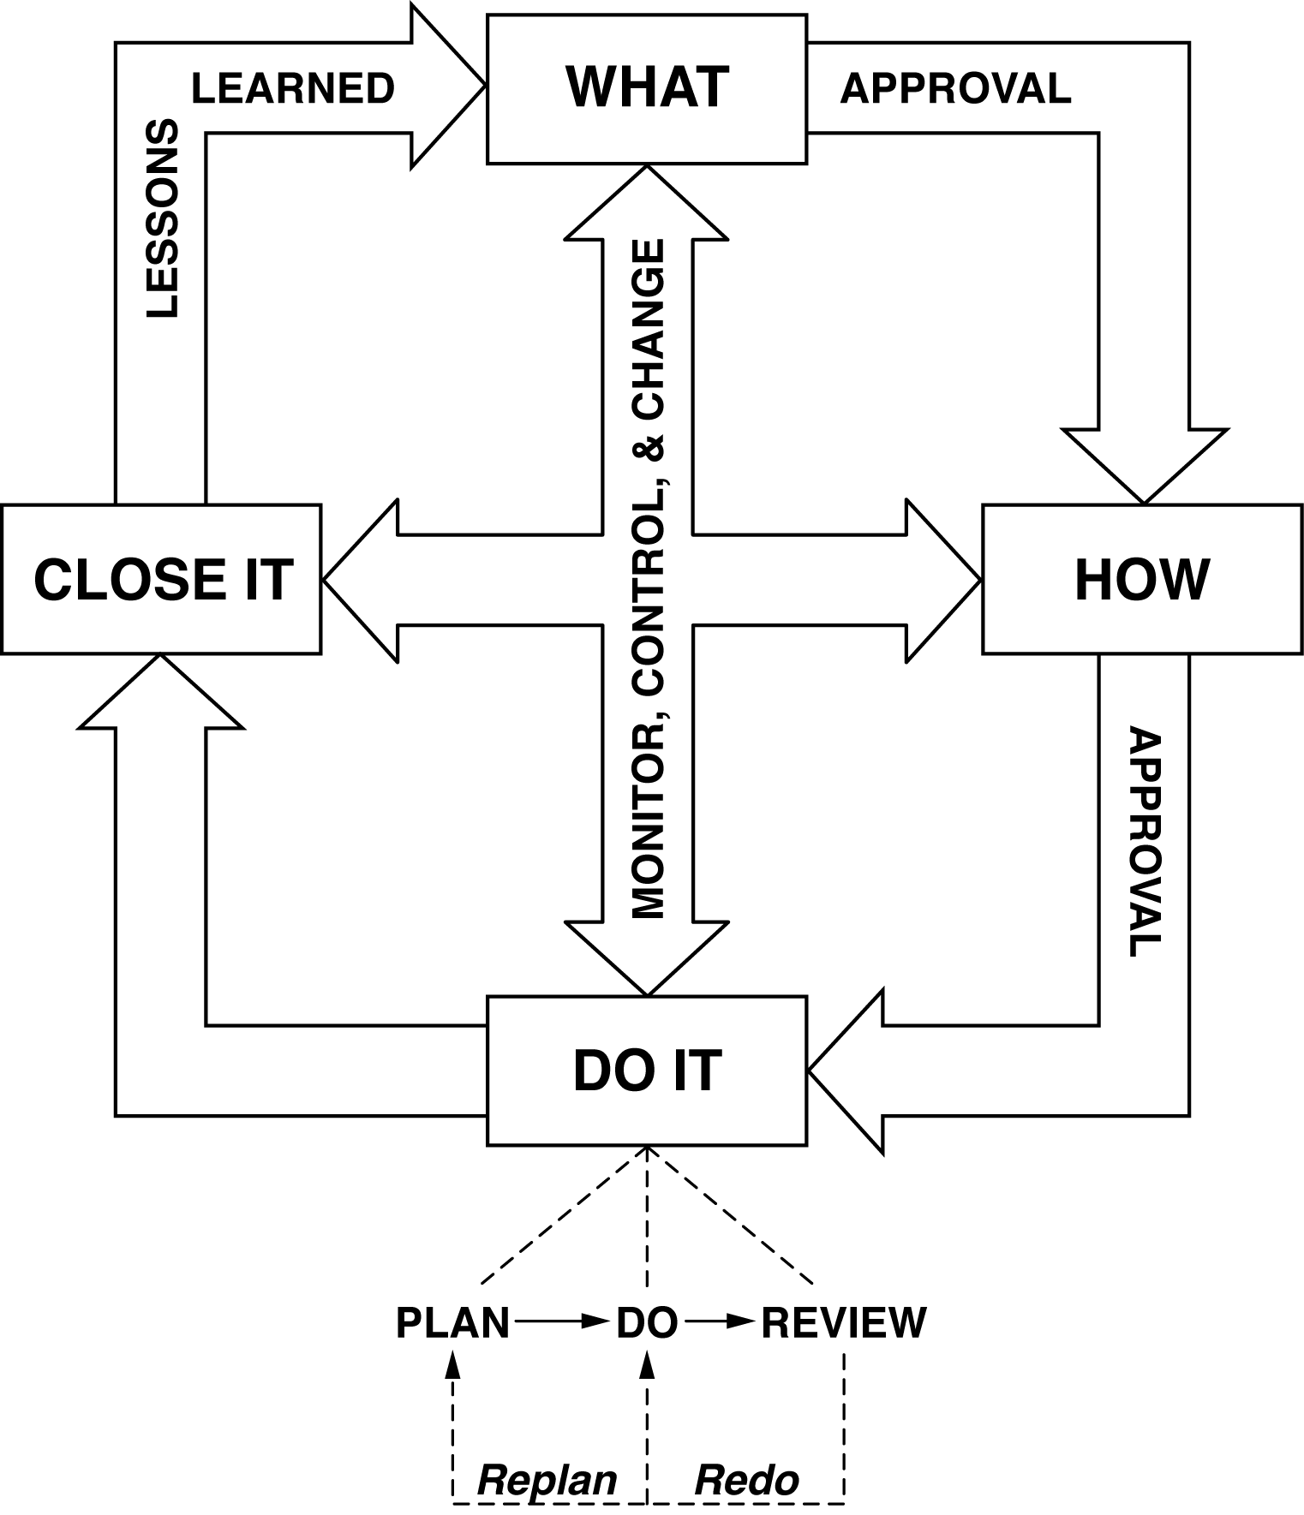

**Case Study: Global Green Technologies**

The vision of Global Green Technologies (GGT) is to be the leading supplier of engineering and water management products. GGT has a strong commitment to the environment, since most of their products contribute to producing clean energy or clean water.

Over the past few years, GGT has experience unprecedented growth. This has caused some major problems:

1) They are running out of engineering lab space which they need to develop more new products as they want to get into new markets.

2) The warehouse resides next to the current Engineering Department. It is outdated and over-crowded. In addition, the “back door” loading area is not large enough to handle some of the raw materials will soon be coming into the facility.

3) GGT management has decided that they want to create goodwill within the community in which the company resides by getting their employees engaged in doing a community service project.

**The new Project Management Office Director is certain that the above problems can be rectified by creating projects out of the work that needs to be accomplished.**

1) **Project A:** There an empty former distribution center (owned by GGT) next to the current warehouse that can be used to create a new and larger warehouse.

2) **Project B:** The emptied warehouse space would be perfect area to put in a new engineering lab, especially since the engineers’ offices are right next door.

3) **Project C:** There is a portion of the city’s foothills that the city would like to turn into a park. The problem is that it is filled with trash, including an abandoned car or two. GGT wants to do their civic duty and organize a trash cleanup day to help the city out.

**With your team, decide which project you want to work on as a case study for this class.**

**MODULE 2 – The Initiation Phase – Part 1: Gathering Requirements**

**Stakeholders and Requirements**

|  |  |  |
| --- | --- | --- |
| **Stakeholder Name and/or Position** | **Requirement #1** | **Requirement #2** |
|  |  |  |
|  |  |  |
|  |  |  |

**MODULE 3 – The Project Manager and the Team**

**Assessing Group Behaviors**

|  |  |
| --- | --- |
| **New group Behaviors** | **High Performing Group Behaviors** |
|  |  |
|  |  |
|  |  |
|  |  |
|  |  |
|  |  |
|  |  |
|  |  |
|  |  |
|  |  |

**Team Stages**

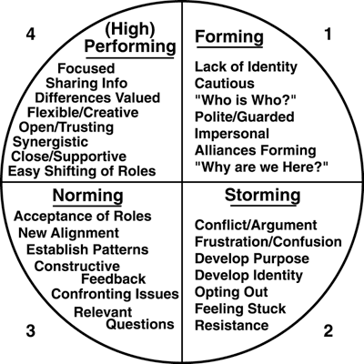

**Managerial Styles:**

* **Task oriented**
* **People Person**
* **“Hands Off” Leader**

**What would cause a team to go “backwards”?**



**MODULE 4 – The Initiation Phase**

**Part 2: Creating the Project Charter**

**Two parts to the Goal Statement:**

* + What is the work that the team will accomplish?
  + AND
  + What is the endpoint signifying completion?

**Project Charter Template**

* Goal Statement
* “Action” Objectives
  + Break Goal into 4-**10** major objectives
  + Each must start with a VERB!!
  + Must include “doing it” AND the endpoint
* Key Deliverables - list what team will deliver
* Scope
  + What is and what is not included
  + Prevents “scope creep”
* Assumptions- Factors that for planning purposes are considered to be true, real or certain.
* Constraints- Facts that limit the project or the team’s options.
* Risks (do NOT do this one on the case study)

**Module 5: The Planning Phase  
Part 1: Planning the Detailed Project Plan**

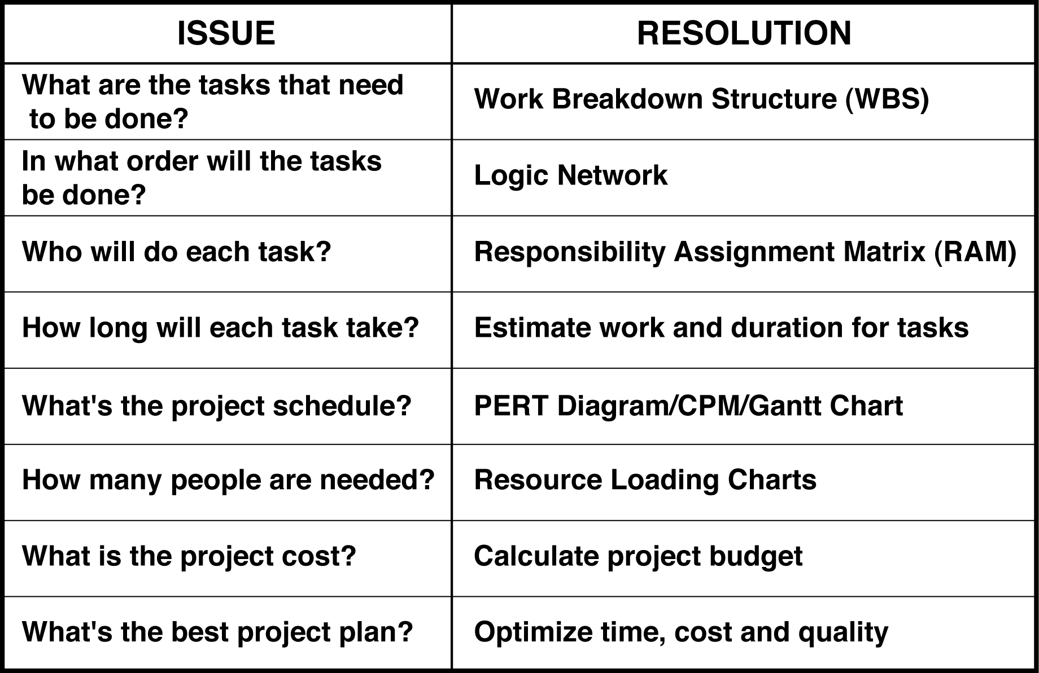

**Sample WBS**

5 WBS

**Sample Logic Network**

5 SMPL LGC NTWK

**==================================================**

**Demo: The Logic Network**

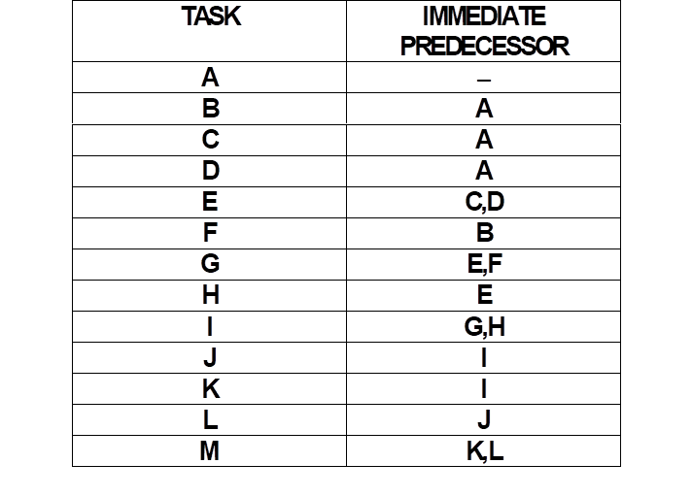

**Logic Network – Example 1**

|  |  |
| --- | --- |
| **TASK** | **Immediate Predecessor** |
| **A** | **--** |
| **B** | **A** |
| **C** | **A** |
| **D** | **A** |
| **E** | **B** |
| **F** | **B** |
| **G** | **C,D** |
| **H** | **C,D** |
| **I** | **F** |
| **J** | **G,H** |
| **K** | **J** |
| **L** | **J** |
| **M** | **E,I,K,L** |

**Logic Network – Example 2**

|  |  |
| --- | --- |
| **TASK** | **Immediate Predecessor** |
| **A** | **--** |
| **B** | **--** |
| **C** | **--** |
| **D** | **A,B,C** |
| **E** | **D** |
| **F** | **D** |
| **G** | **D** |
| **H** | **E,F** |
| **I** | **F,G** |
| **J** | **H** |
| **K** | **H** |
| **L** | **K** |
| **M** | **I,J,L** |

**Module 6: The Planning Phase  
Part 2: Scheduling the Detailed Project Plan**

**Responsibility Assignment Matrix (RAM)**

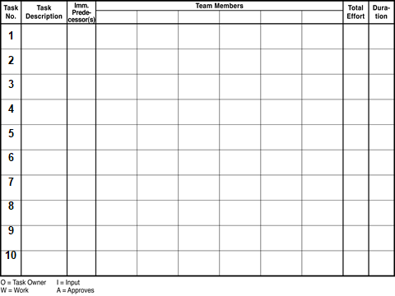

**2 types of Estimates**

**Labor/work effort – goes into the BUDGET**

**Duration – goes into the SCHEDULE**

**Estimating Standard**

**1.0 = 1 week/5 days/40 hours**

**.2 = 1 day/8hours**

**.1 = ½ day/4 hours**

**===========================**

* **Do NOT estimate less than .1**
* **Do NOT go to a second decimal point.**
* **Do NOT consider holidays, vacation or overtime.**

**Demo the PERT Diagram**

6 PERT diagr examp

**Forward Pass: ES + DUR = EF**

**Backward Pass: LF – DUR = LS**

**Float = LF-EF**

**PRACTICE: Do the PERT diagramming**

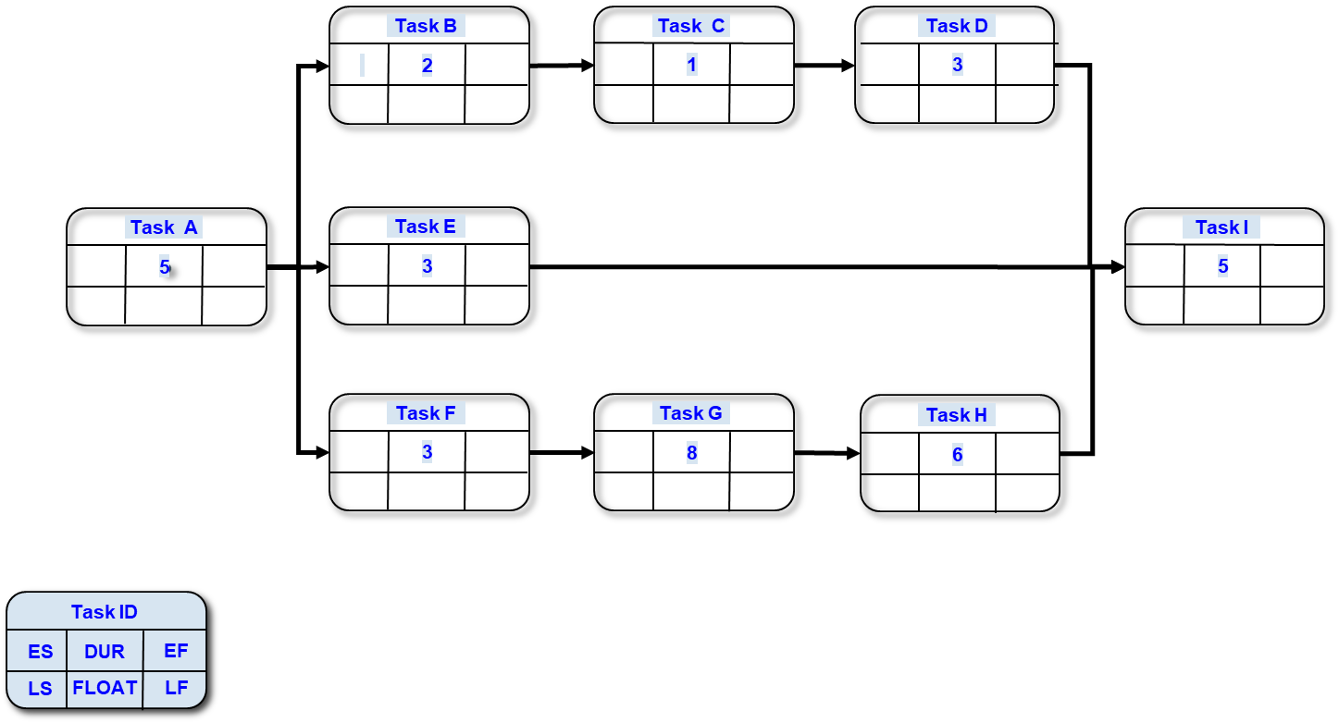

**Forward Pass: ES + DUR = EF**

**Backward Pass: LF – DUR = LS**

**Float = LF-EF**

**Module 7 - The Execution Phase  
Controlling and Monitoring the Project**

**OPTIONS PAPER**

**Project Name:**

**Project Goal Statement:**

**Problem Statement:**

**\*\*The decision to be made is:** *(It is extremely important for you to complete this sentence*

*and include it in this paper as it is the focus for the discussion/meeting.)*

**Options:**  (2 to 4 Maximum)

A - Pros and cons (or risks and benefits)

B - Pros and cons

C - Pros and cons

*NOTE: “Cancel the project” and “Do Nothing” might be viable options to consider.*

**The Team recommends Option** _______. *(You might leave this blank until the*

*presentation of all the options is complete.)*

*NOTE: You might consider doing a “Summarized (high level) Pert Chart” and using it for displaying and explaining your project options.*

*The Options Paper is NOT to be sent out via email or hard copy before the presentation – there is not enough information in it to complete and it might create more misunderstandings. Use it only as a basis for discussion at the presentation when you need a group of managers and stakeholders to make a decision.*

**Project Management – Action Planning**

1. As a result of this training, what do I need to do when I go back to my job (within the next 2-3 days)? Within the next few weeks?
2. Who do I need to update, brief or educate?
3. What additional training might I or my colleagues or team members need?
4. As a result of this training, what do you recommend as “next steps” for Managers in your department to foster more project team “successes” (on time, within budget, delivering expected results in a quality way)?

**Other courses from Dynamic Solutions:**

Available through TEDS:

PM151 – Project Leadership Essentials (2 days)

PMF012 – Managing a Project from Start to Finish (2 days)

No longer available through TEDS:

PMFund010 – Introduction to Project Management Terminology (3.5 hours)

PMFund012 – Managing a Project from Start to Finish (2 or 3 day version)

PM152 –The Essentials of Project Team Membership(2 days)

**Contact info:**

* Project Management Institute
  + *Phone: 610-356-4600*
  + *Website: www.pmi.org*
* Susan Junda - Dynamic Solutions
  + *Phone: 505-459-0436*
  + ***Email: SJunda@DynamicSolutionsNM.com***
  + [***www.DynamicSolutionsNM.com***](http://www.DynamicSolutionsNM.com)

**MOST IMPORTANT POINTS**

**Module 1:**

**Module 2:**

**Module 3:**

**Module 4:**

**Module 5/6:**

**Module 7:**